# Registering in Okta-developer IdP

**SAML: Overview**

[1] SAML is mostly used as a web-based authentication mechanism as it relies on the browser being used as an agent that brokers the authentication flow. At high-level, the authentication flow of SAML looks like this:

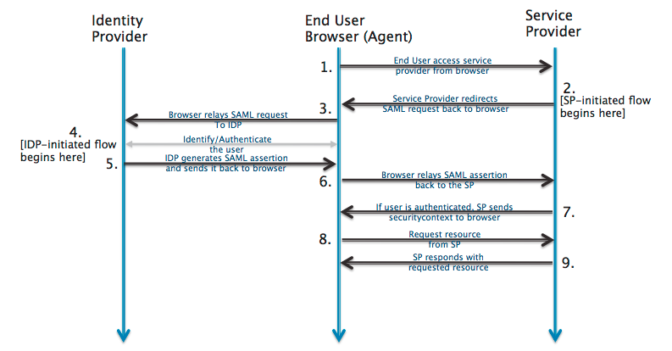

|  |  |  |
| --- | --- | --- |
| Identity Provider | [developer.okta.com](http://developer.okta.com/) | The 3rd-party entity that takes care of the user’s authentication; There are multiple such entities with SAML protocol support, such as [OpenSSO](http://www.oracle.com/technetwork/testcontent/opensso-091890.html), [SSOCircle.com](http://www.ssocircle.com), [OneLogin.com](https://www.onelogin.com), <Salesforce.com>…  For this example, we’ll be using [developer.okta.com](http://developer.okta.com/) |
| End-user browser agent | Pentaho User | User that accesses BA-server via browser |
| Service Provider | BA-server | Pentaho BA Server |

**Registering in Okta-developer Identification Provider (IdP)**

**Note:** Each user that intends to use BA-server needs to register itself first in Okta-developer

## Prerequisites

1. **Have your chosen Service Provider ( i.e. Ba-Server ) metadata xml file at hand**

**Developer/QA only**: if none is created yet, you can leverage on the already existing SP metadata file for SSOCircle.com. For this:

* 1. Go to <https://pentaho.box.com/s/x0s0hcvs13te25clqo5lenmthu6p9cim>
  2. Go to “ssocircle-metadata” folder
  3. Download “pentaho-ssocircle-dev-sp.xml” and rename it to something more identifiable with okta ( e.g. “pentaho-okta-dev-sp.xml” );

1. **Have a certificate file holding the public signing key at hand**

**Developer/QA only**: if none is created yet, we can quickly create one based of the information stored if the service provider’s metadata xml file:

* 1. Create a new (empty) file with extension .cer ( e.g. “pentaho-dev-certificate.cer” )
  2. Open it using an editor of your choice ( Notepad++, Sublime Text, ..)
  3. Add the following content **as-is** to the file:

-----BEGIN CERTIFICATE-----

<certificate-goes-here>

-----END CERTIFICATE-----

* 1. Open your Service provider ( i.e. Ba-Server ) metadata xml file using an editor of your choice ( Notepad++, Sublime Text, ..)
  2. Locate the <ds:X509Certificate> tag
     1. If two such tags exist, we want the one that is inside the <md:KeyDescriptor use="signing"> tag and not the one inside the <md:KeyDescriptor use="encryption">
     2. Copy its contents **as-is ( do not change/edit anything )**
     3. Paste it in the newly created certificate file, replacing the placeholder <certificate-goes-here> with this pasted content
     4. **Roughly put**, your certificate should look something like this:

-----BEGIN CERTIFICATE-----

MIIDUjCCAjqgAwINBgCQYDVQQGEwJGSTEQMA4GA1UE

CBMHVXVzaW1hYTEAoTD1JNNSBTb2Z0d2FyZSBPeTEM

MAoGA1bG8wHhcNMTMwMTAxMTExWhcNMjIxMjMwMTEy

ODAxWjBrMQswMHVVRMA8G1UEBxMGVs7BlLYW/GuHE=

-----END CERTIFICATE-----

## Registering yourself in developer.okta.com

1. Go to <http://developer.okta.com>
2. Click “Get a free developer account”
3. Fill in all fields
   1. Be sure to provide a real email, as a confirmation email will be sent to you.
   2. **Important:** The confirmation email will also provide you with the url for **your** Okta assigned hostname; that is the one that we’ll be using from now on.
      1. **Example:** https://dev-128494.oktapreview.com/
4. Once registration is done, login to **your** okta assigned hostname
5. Click “Admin” (top right corner)
6. Click “Add applications” (right-side “Shortcuts” menu, 1rst option)
7. Click “Create New app”
8. In the app name, place “pentaho”
   1. app logo is optional
   2. leave “app visibility” unchanged
9. click “Next”

|  |  |
| --- | --- |
| **Field Name** | **Field value** |
| Single sign on URL | http://localhost:8080/pentaho/saml/SSO |
| Recipient URL and Destination URL checkbox | Checkbox enabled |
| Audience URI | pentaho |
| Default Relay State | <empty> |
| Name ID format | EmailAddress |
| Application Username | Okta username |

1. Click “Show advanced settings”

|  |  |
| --- | --- |
| **Field Name** | **Field value** |
| Response | signed |
| Assertion Signature | signed |
| Signature algorithm | RSA- SHA256 |
| Digest algorithm | SHA256 |
| Assertion encryption | unencrypted |
| Enable Single Logout | Checkbox: checked |
| Single Logout URL | http://localhost:8080/pentaho/saml/SingleLogout |
| SP Issuer | pentaho |
| Signature Certificate | Upload the certificate addressed in the “Prerequisites” section, step 2 |
| Authentication Context | PasswordProtectedTransport |
| Honor Force Auth. | Yes |
| Saml Issuer ID | http://www.okta.com/${org.externalKey} |

1. In the “Attributes Statements” section add 3 fields:

|  |  |  |
| --- | --- | --- |
| **Name** | **Name format** | **Value** |
| First Name | Unspecified | user.firstName |
| Last Name | Unspecified | user.lastName |
| Email | Unspecified | user.email |

1. In the “Group Attributes Statement” add 1 field:
   1. we will be creating and configuring those groups later on (step 22)

|  |  |  |  |
| --- | --- | --- | --- |
| **Name** | **Name format** | **Dropdown** | **Filter** |
| Pentaho Role | Unspecified | StartsWith | Pentaho: |

1. Click the “Preview SAML Assertion” button
   1. **Save this xml metadata information in your local machine**.
   2. **Based on the information we’ve typed so far, this is Okta offering us a auto-generated “Pentaho Service Provider Assertions” that we can add to out metadata xml file**
   3. Open your service provider’s metadata xml file
   4. Scroll all the way down: after the </md:EntityDescriptor> tag click enter and paste the xml content Okta has just provided us.
   5. Save and close the file.
2. (Back to the wizard) Click “Next”
3. Check the radio button “I'm an Okta customer adding an internal app”
4. Enable the checkbox “This is an internal app that we have created”
5. Click Finish.
6. Top Menu Bar, select “Applications > Applications”
7. Select app “pentaho”
8. Select the 2nd menu tab “Sign On”
9. On the SAML 2.0 section, click the “Identity Provider Metadata” link
   1. **Save this xml metadata information in your local machine**.
   2. **This is Okta offering us a auto-generated “Okta IdP Metadata” xml.**
   3. Open the IdP metadata xml file and search for the “entityID”; it should hold a key of type http://www.okta.com/${org.externalKey}
      1. Example: http://www.okta.com/exk58mn1xrPYSE1lA0h7
   4. **Save this entityID value; later on, we will need to place it in the pentaho.saml.cfg “saml.idp.url” key**
10. (Back to the page) Top Menu bar , select “Directory > Groups”
11. In the “Groups” page, section add 3 groups:

|  |  |
| --- | --- |
| **Name** | **Description** |
| Pentaho:Administrator | Pentaho BA-server’s Administrator Role |
| Pentaho:Power User | Pentaho BA-server’s Power User Role |
| Pentaho:Report Author | Pentaho BA-server’s Report Author Role |

1. (Back to the page) Top Menu bar, select “Directory > People”
2. Select your user
3. Select the 1st tab , “Applications”
4. Click “Assign Applications”
5. Click “Assign App“ on the “pentaho” application line; click “Save”;
6. Select the 2nd tab, “Groups”
7. In the search bar, start typing “Pentaho”
8. Add **at least** “Pentaho:Administrator” group to your user ( you can add others if you choose to do so )
9. Done

## Recap

We have:

1. Registered onto developer.okta.com
2. Added an application called “pentaho”, passed the endpoint for it ( http://localhost:8080/pentaho/saml/SSO ) and have configured it to work with SAML 2.0
3. Created Okta “groups” that start with a “Pentaho:” prefix and assigned those to our user ( and only those )
4. Configured the SAML response so that the authenticated response ( from Okta to Pentaho ) also carries a list of attributes, namely those “Pentaho:*” groups
5. Got the idp and sp metadata xml files
6. Got the Okta url to use from the “entityID” value

**Q&A**

## Q1 | Do I need a certificate to sign the authentication requests?

Yes.

For this sample, we are using a certificate provided by spring-security-saml, stored in a .jks ( keystore file ).

It’s already bundled in the saml-authentication-provider sample ( jar:/security/keystore.jks ).

You can get the original here: <https://github.com/spring-projects/spring-security-saml/blob/1.0.1.RELEASE/core/src/test/resources/org/springframework/security/saml/key/keystore.jks>

This certificate is used by some IdP’s, such as SSOCircle.com and okta.developer.com.

If you plan to connect to some other IdPs, then you must ensure you update the keystore file to include the certificate provided by that Identification Provider.

1. http://developer.okta.com/docs/guides/saml_guidance.html